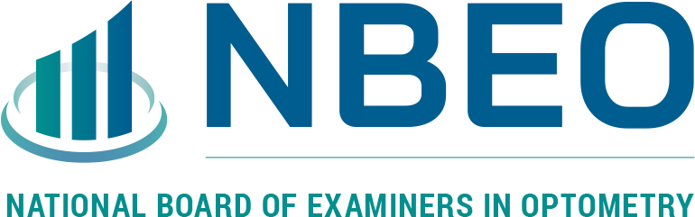

The National Board of Examiners in Optometry (NBEO) is seeking an Associate Director of Psychometrics and Research to assist the organization.

Founded in 1951, the National Board of Examiners in Optometry is an independent, non-governmental, non-profit whose examinations are universally accepted for optometric licensure in the United States and internationally. NBEO’s mission is to serve the public and the profession of Optometry by developing, administering, scoring, and reporting results of valid examinations that assess competence. NBEO has a full-time staff of 18 and utilizes over 100 optometrists as subject matter experts nationwide in support of its examination programs. NBEO is one of the few national boards in any profession with a repertoire of exams that include computer-based tests, an advanced competence exam, and clinical skills test using standardized patients at the National Center of Clinical Testing in Optometry. We work to maintain the best possible environment for our employees, where people can learn and grow with the company. We strive to provide a collaborative, creative environment where each person feels encouraged to contribute to our processes, decisions, planning and culture.

This role is a full-time, onsite position based in Charlotte, NC.

Reporting to the Executive Director, the Associate Director of Psychometrics and Research is responsible for providing statistical analysis and interpretation of results as it applies to the organization’s focus of developing, administering, and scoring NBEO examinations. This will require leadership both internally and externally regarding issues of exam development, security, and reporting.
Essential Duties and Responsibilities include the following.
- Provide support regarding examination development to pertinent staff members.
- Participate in all relevant Committee and Council meetings.
- Provide presentations as needed for the NBEO Board of Directors.
- Participate in research projects of examination validity along with psychometric consultants.
- Provide direct support in the development of new exams or practice exams.
- Participate in meetings as necessary with the Executive Director with external organizations such as state regulatory boards, statistical vendors, software vendors, legal team, ARBO, and ASCO.
- Review all exam items to ensure the items meet NBEO item-writing guidelines.
- Periodically, conduct item studies for each NBEO exam.
- Participate in Practice Analysis/Content Validation Studies of NBEO exams.
- Update and maintain the NBEO Item Writing Guidelines in collaboration with the Directors of Part I, II, III, ACMO and CPDO examinations.
- Participate in equating exam forms along with psychometric consultants including selecting and implementing appropriate methods.
- Ensure quality control of reported scores.
- Perform and monitor statistical analysis required of date reporting and interpretation of results, which include data collection, equating, linking and scaling, and psychometrics analysis utilizing psychometric and statistical software.
- Conduct research and special analyses and contribute to the development of data interpretation materials and publications.
- Assist in developing, designing, and documenting operational procedures and statistical guidelines.
- Develop organizational position on statistical issues to professional associations and other agencies.
- Represent organization’s position on statistical issues to NBEO staff, NBEO committees, professional associations, and other agencies.
- Develops sufficient knowledge of statistical procedures, psychometric and statistical methods to position NBEO at the leading edge of psychometric research and best practice across healthcare professional organizations.
- Applies sufficient knowledge of statistical procedures, psychometric and statistical methods to work independently on most aspects of statistical analysis while receiving instruction and guidance in other areas.
- Communicate with candidates, educational program directors, instructors, and other NBEO stakeholders, as requested.
- Prepare Board reports on exam scoring and other related areas.
- Perform other tasks as requested by Executive Director.
- Other duties may be assigned.

Qualifications
- Education: Ph.D. in Psychometrics, Educational Measurement or Similar
- Experience: At least five years of experience is desired.
- Psychometric Skills Required: Knowledge of or experience in test equating methods, IRT (specifically Rasch modeling), classical test theory and testlets.
- Additional Psychometric Skills Desired: Knowledge of or experience in test development, best practices in item-writing, exam blueprint development, survey development, and the field of licensure testing.
Additional General Skills Required: Able to work collaboratively as part of a multi-disciplinary team, excellent written and oral communication skills, ability to handle complex tasks, strong organizational skills, ability to balance multiple competing priorities and maintain a high degree of responsiveness.
We work to maintain the best possible environment for our employees, where people can learn and grow with the company. We strive to provide a collaborative, creative environment where each person feels encouraged to contribute to our processes, decisions, planning, and culture.

To support the health and safety of NBEO employees and optometry candidates, NBEO requires employees to be fully vaccinated against COVID-19 or to have received an approved accommodation based on medical condition or sincerely held religious belief or practice.

Applicants should send their resume and cover letter to marla.doddo@optometry.org.

